**Web Hosting Features**

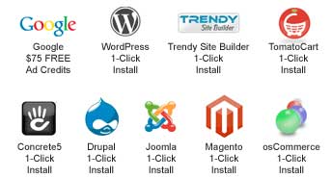

|  |  |
| --- | --- |
| Feature Overview | World Class Technology |
| Disk Storage 100MB / 250 MB/500 MB/1GB | Dual Quad Processor Performance Servers |
| Domain Hosting | UPS Power Backup |
| Free Drag and Drop Site Builder (New!) | Diesel Generator Backup Power |
| Support International Domain Names | Linux Operating System |
| POP3/POP3 Secure E-mail Support | Customized Apache Web Server |
| IMAP/Secure IMAP E-mail Support | 24/7 Network Monitoring |
| 3 Different Webmail (Web Based E-mail) Solutions | Courtesy Site Backups |
| Forwarding E-mail Accounts | Multiple 10 Gigabit Ethernet Connections |
| Unlimited GB of Site Transfer | CGI / Databases |
| Subdomains Unlimited | MySQL Databases |
| cPanel Account Control Panel | PostgreSQL Databases |
| FTP Access | CGI-BIN |
| Web File Manager | CGI Library |
| Secure Shell (SSH) Access | PHP 5 |
| Server Side Includes | Support for Custom PHP.INI Files |
| Hotlink Protection | Perl 5 |
| Override .htaccess Support | Python |
| Log Files | Ruby/Ruby on Rails |
| Site Statistics | MySQL 5 Database Server |
| Customizable Error Pages | PostgreSQL Database Server |
| Custom Cronjobs | Javascript Support |
| Spam Assasin Protection | DHTML Support |
| Multimedia Features | Flash Support |
| Streaming Video Support | Shockwave Support |
| Streaming Audio Support | SimpleScripts 1-Click Script Installs |
| Real Audio and Video Support | Search Engine Submission |
| MIDI File Support |  |
| Add Custom MIME Types |  |